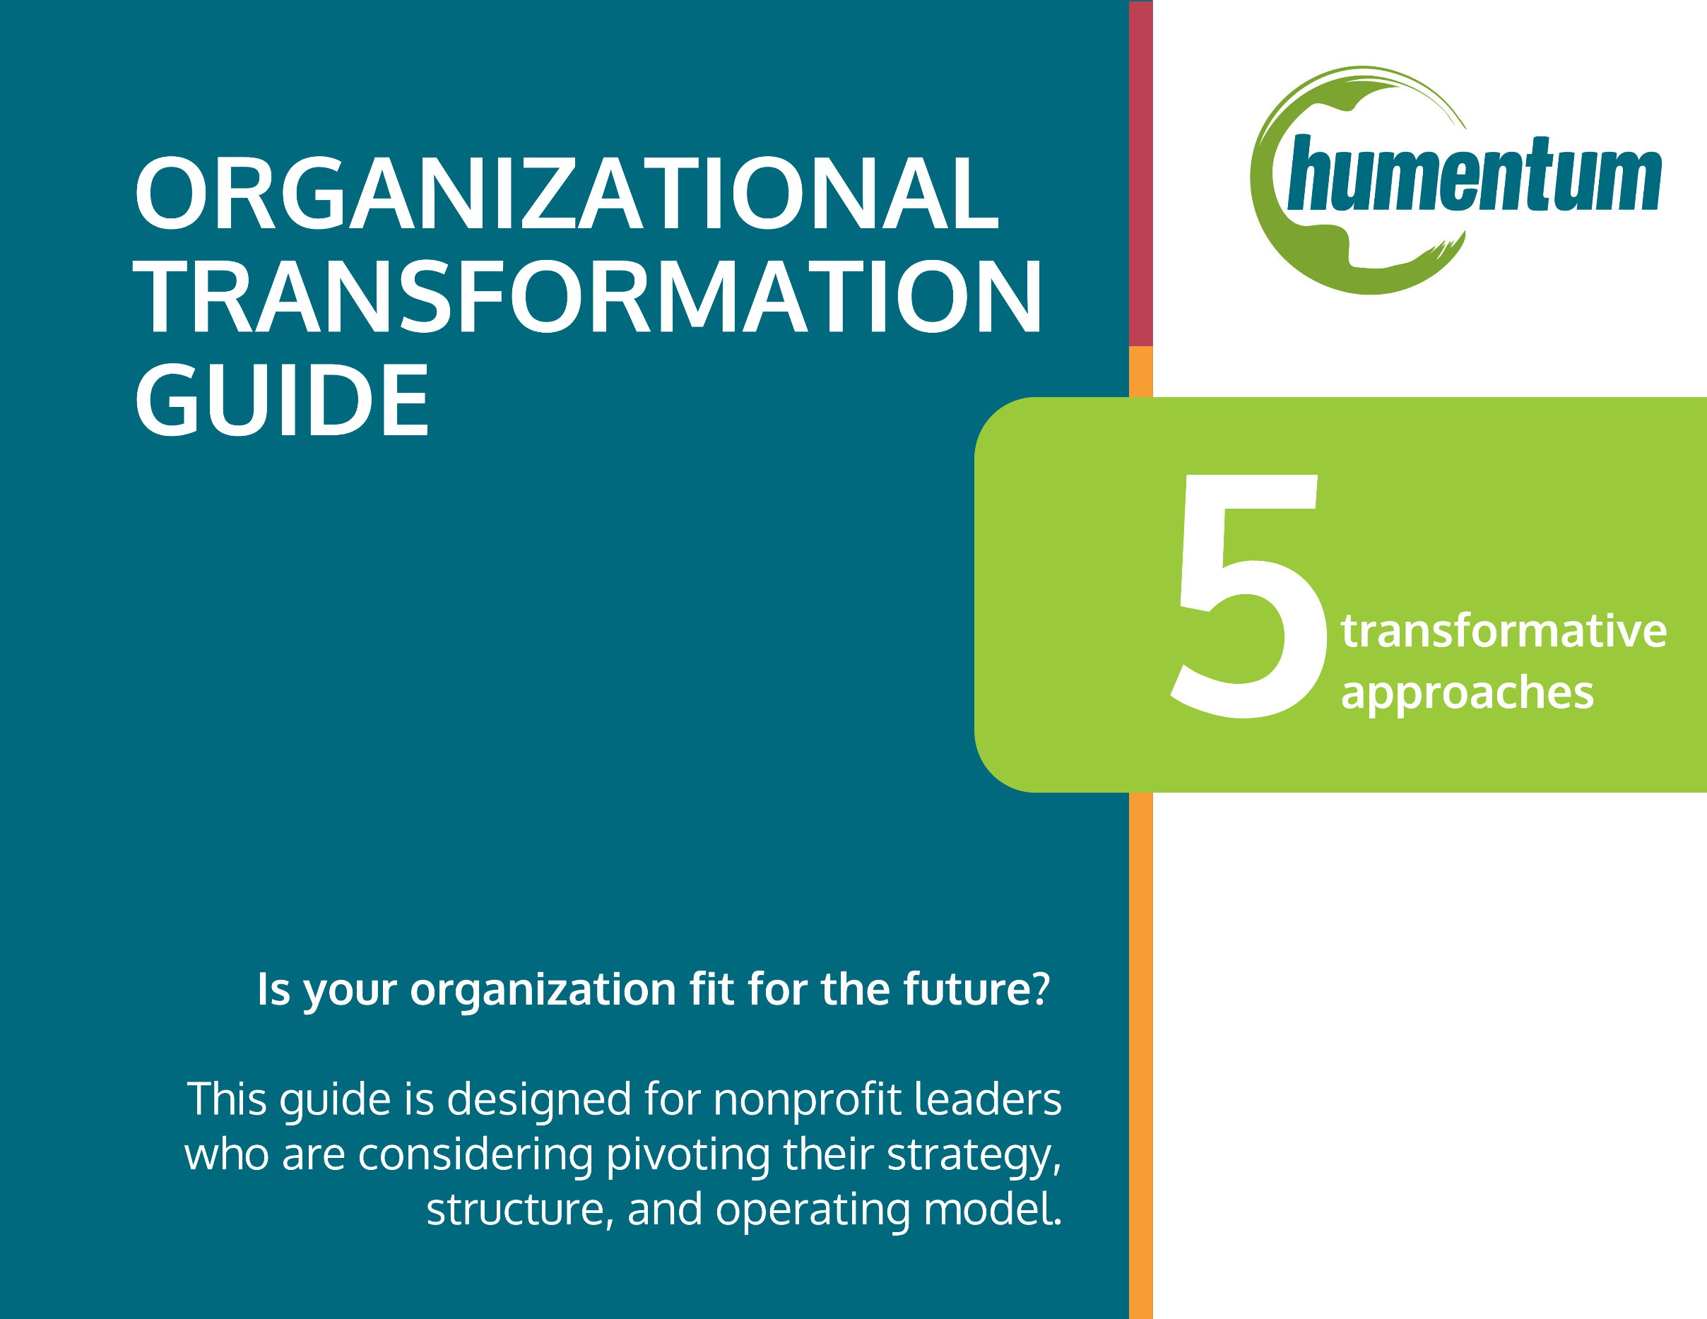

As the global development and humanitarian sector changes at a rapid pace, nonprofit organizations will need to transform.

Your organization may be exploring the possibility of alternative operating structures. You are not alone!
No organization can stay the same for long. As the world changes at an ever-increasing pace, leaders must continually ensure that their organizations are fit-for-the-future – that their strategy, structure, and operating model align to achieve the greatest impact possible. Many organizations will need to focus on pivoting or rightsizing their structural model, consolidating through strategic partnerships, or sunsetting operations through closure.
Making organizational transformation decisions in a complex operating environment can be challenging. Doing so in a deliberate, inclusive, values-based manner is equally important. And yet getting it right is more important than ever before.
This Organizational Transformation Guide has been designed by and for nonprofit organizations considering alternative operating structures. Many thanks to the Transforming INGO Models for Equity (TIME) and Humentum Transforming Organizational Models working groups for their insights and contributions, which are included throughout this Guide.
On the next page, you will find instructions on how to use this guide. We intend it to be iterative and help your organization understand its options, facilitate dialogue and encourage reflection, and move to actionable steps to transform your operating model.
Change is hard – and messy. If you need an unbiased, trusted source to guide your organizational transformation journey, we offer a consultancy to accompany you. Reach out to client@humentum.org to get started.
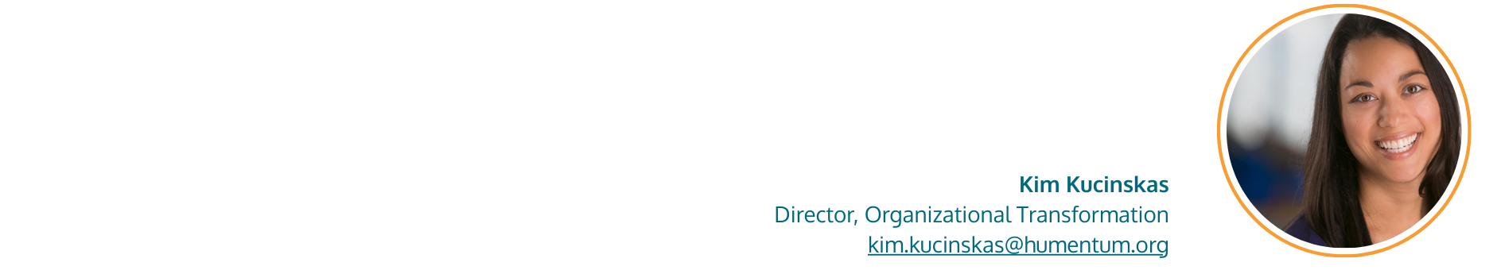

How to use this Guide
Step 1: Take a moment to assess your readiness for transformation by answering the Introspection and Assessment Guiding Questions (page 3).
STEP 2: Review the Five Approaches for Transforming Your Operating Model (page 4) that your organization can take.
Step 3: Complete the Approaches for Transformation Discussion Questions (page 5) to help you decide which option is your best path forward.
Note: This toolkit specifically focuses on pivoting through reimagining your structural model and consolidations through strategic partnerships.
If you decide that consolidation through strategic partnerships might be the right path for you, then follow the steps below: | If you decide that pivoting through reimaging your structural model is the right path for you, then follow the steps below:
Step 4A: Review the Consolidation Typology table (page 8) to help you compare options. Ask yourself: What need is driving this change? How important is it to maintain some level of organizational autonomy? What are we trying to gain? What are we willing to give up?  Step 5A: If you have a shortlist of potential partner organizations, assess them using the Strategic Partnership Checklist (page 11) to ensure alignment and a win-win collaboration. | STEP 4B: Review the Structural Model Typology table (page 16) to help you compare options.  STEP 5B: Review the set of considerations in the Structural Model Considerations table (page 19). These questions will help set you up for decision-making and analysis. Before you begin, ask yourself, "What perspectives should be included in these conversations? Who should participate?"  STEP 6B: Complete a Current and Future State: A Gap Analysis for Your Organization (page 21) to better understand what actions you should prioritize.
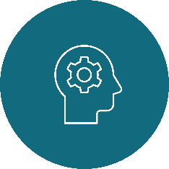
Remember, there is no one-size-fits-all approach to this kind of change. We encourage you to contextualize these resources to best meet your specific needs.
If you need trusted, outside expertise, Humentum offers a consultancy where we accompany your organization to assess and transform your strategy, structure, and operational model.
And if you find yourself needing additional support, Humentum offers a consultancy where we will accompany you on this journey, offering resources and insights along the way. [link to web page]

Introspection and Assessment
Guiding Questions
It is tempting to start by jumping right to potential model scenarios, but a more deliberate process will involve a degree of introspection and assessment. To begin, we encourage you to review the questions laid out below.
Gather the right group of people to discuss the questions together. By the time you have completed your reflection, you should be able to answer the following questions:
- Are we ready to do this work?
- Do we know where we are going and what is important to us as we make decisions?
- How will we ensure that our values are reflected in the change process?
Introspection and Assessment: Are we ready to do this work? | Reflection
Who/what is driving the need for organizational transformation?
Are our key stakeholders supporting or resisting transformation?
Are we aligned as a leadership unit?
Do we have the resources (people, time, money) needed to make the change?
Vision and Principles: Do we know where we are going and what is important to us as we make decisions?
Where do we hope to be in 10 years? What is our vision of success?
What is our unique value? What is unique to us that should be preserved?
What role can and should we play in the broader ecosystem? Does strategy align with that role(s)?
What are the common set of principles that will inform how we get there?
Process: How will we ensure that our values are reflected in the change process?
Do we have the culture, level of trust, and change management capabilities necessary to set us up for success in this moment of transformational change?
What perspectives should be included in these conversations? Who should participate?
How do we make decisions in our organization? Who makes decisions in our organization?
What does transparency look like in our organization? How do we make sure that our communication is accessible?

Five Approaches for Transforming Your Operating Model
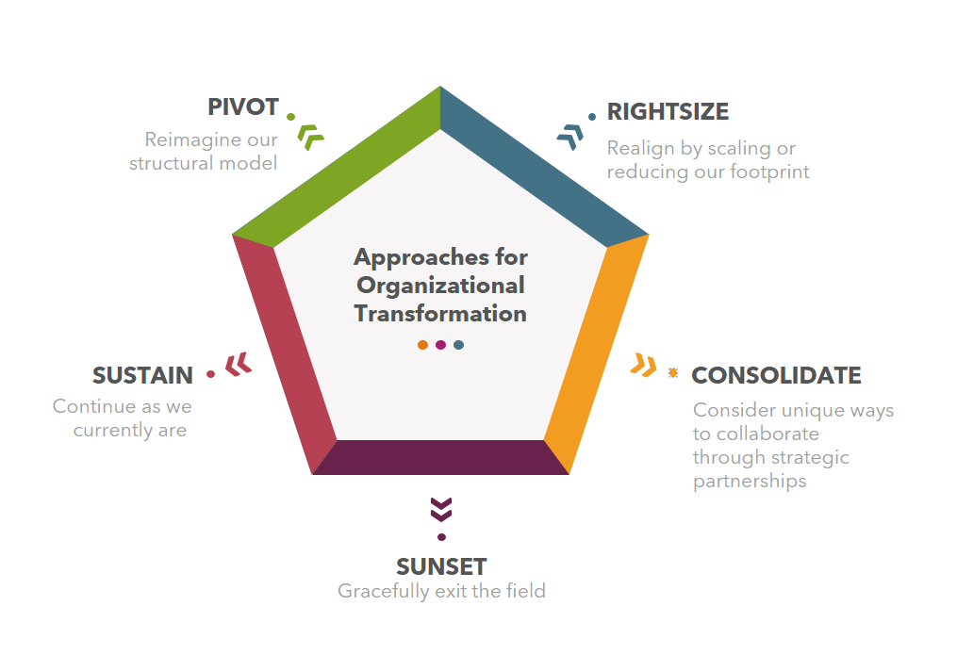

Which of the approaches above is your organization currently considering?
- If your organization is actively considering pivoting its structural model or consolidating through strategic partnerships, continue to the relevant sections of this workbook.

- If you are currently considering your options, see the discussion questions below.

Approaches for Transformation
Discussion Questions
How does your organization need to transform? | Pivot  Reimagine our structural model | Rightsize  Realign by scaling or reducing our footprint | Consolidate  Consider unique ways to collaborate through strategic partnerships | Sunset  Gracefully exit the field | What other options should you consider?
Does this approach help or hinder us in meeting our mission? Would it increase our impact?

Will this approach maintain the elements of our organization that we want to preserve?

Can this approach reflect our core values? Would it help achieve our long-term vision?

Is this approach financially stable? Would it increase our efficiency and sustainability?

What legal considerations do we need to take into account?

How would this approach enable us to shift power locally?

How would this approach enable effective partnerships? How will it impact our legitimacy with different stakeholders?

What are the brand implications of this approach?

Is this fundable? How much do we need to raise for this approach to be viable? Will current funders support this model?

What other questions should we be asking ourselves?

Consolidate pathway
Consider unique ways to collaborate through strategic partnerships
Collaboration models define how nonprofits work together to achieve shared goals—whether by merging, sharing resources, or partnering on specific initiatives. These partnerships can be temporary or long-term and may or may not change the core governance of each organization.
We created the typology below for commonly understood language to compare models, engage in internal assessment and reflection, and make decisions.
As you review the options below, remember that along with shifts each independent organization might make, regions and sectors must begin to consider strategic partnerships to create efficiencies and enhance impact. New models can emerge that align INGOs, civil society organizations (CSOs), and funders in innovative ways, helping to reduce unhealthy competition and respond to resource constrictions.
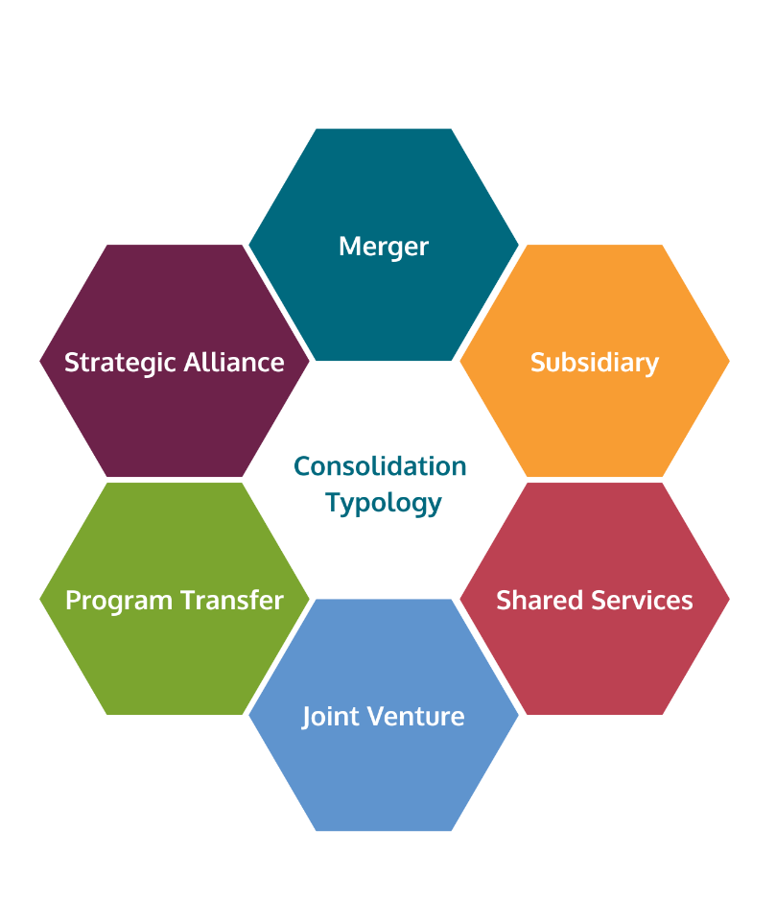
As you review the different models below, consider the following questions:
- What need is driving this change? Examples may include: to reduce costs, reduce headcount, extend the life of our assets, expand into new markets, etc.
- How important is it to maintain some level of organizational autonomy?
- What are we trying to gain?
- What are we willing to give up?

Consolidation Typology Table
Defining collaboration models
Criteria |  | Merger | Subsidiary | Shared Services | Joint Venture | Program Transfer | Strategic Alliance
Definition |  | A highly integrated collaboration where two or more nonprofits legally combine into a single entity, dissolving the original organizations. | A nonprofit establishes or takes over another legally separate nonprofit. While there is a legal connection and the parent company maintains control, the subsidiary maintains some operational independence. | Multiple separate organizations share administrative functions (e.g., HR, IT, finance) to reduce costs, while remaining independent. | Two or more nonprofits form a temporary or permanent new legal entity for a shared initiative while remaining separate entities. | One nonprofit fully transfers a program or initiative from its portfolio to another organization that is better suited to manage it, while maintaining a separate entity. | Two or more nonprofits collaborate on a common goal without legal integration. Could involve joint programs, advocacy, or fundraising.
Purpose of the collaboration  What is the underlying purpose behind the structure choice? |  | To achieve greater impact, reduce duplication, strengthen financial stability, or expand services. | To expand reach while maintaining some legal or operational separation, or to comply with regulations in different regions. | To increase efficiency, reduce overhead, and improve service delivery while keeping independent programs. | To collaborate on a specific project, service, or initiative without merging fully. Often used for large-scale projects requiring multiple stakeholders. | To ensure the continuity of a program that the original nonprofit can no longer sustain. | To leverage each other’s expertise, networks, or resources while remaining independent. Often used for advocacy, policy work, or joint programming.
Level of integration  Does this partnership require organizations to fully combine, partially collaborate, or loosely partner? |  | Full integration | High integration | Medium integration | Medium integration | Low to medium integration | Low integration
Legal and governance structure  Are the organizations combined or do they remain separate legal entities? |  | Two organizations legally combine into one. | One organization owns or controls another, but both remain legally separate. | Each nonprofit  Remains legally  independent. | A new entity is legally formed and jointly controlled. | Receiving organization gains full control of the program. | No legal integration; a formal agreement guides collaboration.
Financial control and responsibility  How are funds managed? Who takes on financial risk? |  | Fully integrated finances. | Parent owns ultimate financial accountability; subsidiary often manages its own budget and cash flows (varies). | Costs are shared per agreement, but finances remain separate. | Joint financial commitment; costs and revenue are shared. | Receiving organization assumes full financial responsibility. | Separate finances; may co-fund projects or initiatives.
Operational control and autonomy  Who has decision-making power? |  | One unified decision-making structure. | Subsidiary often has operational autonomy, but ultimate governance decisions are often made by the parent based on the design of the governance model. | Each organization retains programmatic autonomy. | Decision-making is shared or structured per the agreement. | The receiving nonprofit manages the program independently. | Independent operations; coordination in specific areas.
Resource and cost sharing  How are administrative functions and staff integrated? |  | Staff, services, and operations are fully integrated. | Some shared services, but separate operations. | High cost/resource sharing for administrative functions. | Shared resources only for the venture. | Some temporary transition support may be provided. | Limited or no cost/resource sharing.
Risk and liability  Who is responsible for risks, compliance, and liabilities? |  | Shared liability under one entity. | Parent nonprofit may assume some liability. | Shared liability only for specific services. | The new entity holds liability; parent orgs may share risks. | Receiving organization assumes full liability. | Each organization retains its own liability.
Branding and identity  Do both names remain, or is one absorbed into the other? |  | One brand; may retain elements of both. | May have its own brand or adopt the parent's branding. | Separate branding. | May have a separate brand. | May retain original program branding or rebrand. | Both brands remain separate.

Strategic Partnership Assessment Checklist
Assess a potential partner to ensure alignment and a win-win collaboration.
1. Mission & Strategic Fit
Mission Alignment – Does the potential partner’s mission complement or strengthen yours?

Values & Culture – Do both organizations have similar values, work ethics, and leadership styles?

Program Synergy – Will combining programs/services enhance impact without redundancy?

Geographic Alignment – Do both organizations serve similar areas, or would this partnership expand reach?

2. Organizational Values & Work Environment
Core Values Alignment – Do both organizations emphasize similar values (equity, transparency, accountability, etc.)?

Workplace Environment – Are they structured and formal or flexible and informal?

Commitment to DEI (Diversity, Equity, Inclusion) – Do both organizations share a similar approach to DEI initiatives?

3. Leadership & Decision-Making Style
Leadership Philosophy – Do the leadership teams have similar management styles (hierarchical vs. collaborative)?

Decision-Making Process – Are decisions top-down or consensus-driven?
Risk Tolerance – Are both organizations comfortable with innovation, or is one more risk-averse?

4. Financial & Legal Health
Financial Stability – Is the partner organization financially sound? Review:

- Recent audited financial statements

- Revenue sources (grants, donations, earned income)

- Debt obligations and liabilities

Fundraising & Revenue Compatibility – Do both organizations rely on similar funding streams, or will they compete?

Legal & Compliance Status – Is the partner in good standing with regulators (e.g., nonprofit status, tax filings, registrations)?

Liabilities & Risks – Are there legal risks (e.g., pending lawsuits, regulatory violations, compliance issues)?

5. Leadership & Governance
Board & Executive Alignment – Do the leadership teams support the potential partnership?

Decision-Making Process – Is there clarity on how decisions will be made post-merger/subsidiary/joint venture?

Governance Model Compatibility – Do board structures, bylaws, and policies align?

6. Operational & Organizational Capacity
Staffing & HR Policies – Are staffing levels, salaries, benefits, and HR policies compatible?

Technology & Systems – Are IT systems, databases, and operational workflows compatible?

Program & Service Delivery Models – Will programs integrate smoothly without disruption?

7. Communication & Conflict Resolution
Communication Style – Do they prefer structured reporting or open discussions?

Transparency & Information Sharing – Do staff feel included in decision-making, or is information closely guarded?

Conflict Resolution Approach – How does the organization handle internal disagreements?

8. Cultural Integration Plan
Culture Integration Strategy – Is there a plan to align cultures and bring staff together?

Leadership & Staff Buy-In – Have staff at all levels been engaged in the partnership discussion?

Change Management Approach – Will staff receive training, town halls, or workshops to ease the transition?

9. Brand, Communications & Stakeholder Impact
Reputation & Public Perception – Does the organization have a strong reputation and credibility?

Donor & Funder Considerations – Will funders support the partnership, or could it risk losing key funding?

Stakeholder Communication Plan – Is there a strategy to communicate changes to staff, donors, and beneficiaries?

10. Exit Strategy & Contingency Planning
Defined Success Metrics – How will success be measured (financial health, program growth, efficiency)?

Conflict Resolution Plan – How will disagreements be handled if the partnership faces challenges?

Exit Strategy – If the partnership doesn’t work, is there a clear process to unwind it?

Red Flags to Watch For:
❌ Leadership teams that clash or have opposing management styles.
❌ High staff turnover or low employee satisfaction in one of the organizations.
❌ Significant differences in pay structures, benefits, or workload expectations.
❌ Lack of transparency or communication from leadership.
❌ Resistance to cultural integration without a clear plan to address concerns.

Final Decision-Making:
✅ Are both organizations better off together than apart?
✅ Do the benefits outweigh the risks?

✅ Is there a clear, well-documented integration plan?
If most of these criteria align positively, the partnership is more likely to be a win-win.
If there are major misalignments, it may be necessary to adjust the structure, negotiate terms, or reconsider the partnership.

Pivot pathway

Reimaging your structural model

In 2024, a working group of leaders from Humentum member organizations co-created a practical guide to organizational models for INGOs who want or need to transform their structure.

A structural model is the skeleton of an organization. It defines how a nonprofit is set up internally—how it governs itself, how decisions are made, and how different locations or entities relate to each other. Its design should lead directly to achieving the organization's goals, which is why structure is vital. Both a rocket and a plane can fly, but they do it differently to reach different destinations.

We created the typology below for commonly understood language to compare structures, engage in internal assessment and reflection, and make decisions.

As you look at the models, it helps to recognize that each organization's structure is the result of its unique history, purpose, environment, and constraints. You may find that your organization operates primarily as one model but has elements from others that suit its needs and purposes. At the same time, even two organizations that share a primary model will vary. Don't worry if your current model doesn't fit neatly into one definition; choose the one that's most accurate.

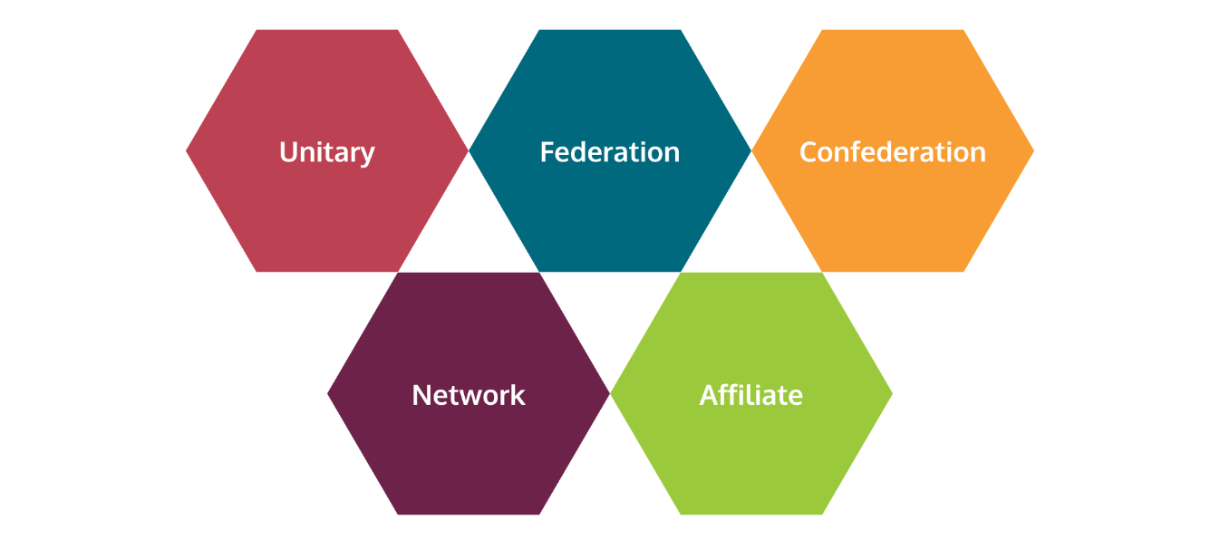

Structural Model Typology Table
Criteria | Unitary | Federation | Confederation | Network | Affiliate
Definition | Centralized structure with a single headquarters or global services function that maintains some level of control over operations.  Branch offices or local chapters, if they exist, have varying degrees of autonomy and decision-making authority within agreed upon parameters and primarily implement policies and programs. | Central body and semi-autonomous local or regional chapters. Power is shared between the central organization and its chapters.  The central body typically sets the overall strategy and provides support, while local chapters have significant autonomy in day-to-day operations and can adapt to local needs. | A loose association of largely independent organizations. The central body in this model is relatively weak, serving mainly to coordinate activities and share resources.  Member organizations retain most of their sovereignty and decision-making power. | A decentralized structure where multiple independent organizations collaborate towards common goals.  There may be a coordinating body, but it doesn't have authority over member organizations.  Instead, it facilitates communication, resource sharing, and joint initiatives. | Separate legal entities that are associated with a parent organization.  They may be created for various reasons, including asset protection, expanded lobbying opportunities, or to handle specific programs or activities.  Affiliates often share common goals, resources, and may have overlapping boards with the parent organization.
Purpose of the  Structure  What is the underlying purpose behind the structure choice? | This structure relies on having a common purpose and way of working. | The structure relies on a common purpose and relatively high variation in ways of working. | The structure relies on a relatively high level of variation of purpose and way of working. | The structure provides an infrastructure for shared learning and communication. | The structure meets a specific need (legal, financial, or programmatic)
Degree of  Centralization  How centralized is control over operations and decision-making? | Center has significant control | Center has control | Center has minimal control | No center | Varies
Autonomy of  local units  How much decision-making power do local units have over operations and programs? | Local units have minimal autonomy | Local chapters have autonomy | Local chapters have significant autonomy | Independent entities have full autonomy | Varies
Decision-making  Who is accountable for making the decisions? Who gets to decide how decisions get taken? Who has decision rights over strategy, decision-making, policies, and resource allocation? | Centralized | Shared between center and local chapters | Consensus-based | Consensus-based | Varies
Risk and accountability  Who bears the risk? | Centralized | Shared between center and local chapters | Local chapters | Independent entities | Varies
Resource generation  Who has control over resource generation? | Centralized | Shared between center and local chapters | Shared between center and local chapters | Independent entities | Independent entities
Resource allocation  Who has control over resource allocation? | Centralized | Centralized | Shared between center and local chapters | Independent entities | Independent entities
Legal structure  What is the legal structure holding this entity together? | There is one single primary registration with potential registration of branch offices. | Local chapters may or may not be separate legal entities. | Local chapters may or may not be separate legal entities. | Coordinating body may be a separate legal entitle; independent entities may or may not be separate legal entities. | Separate legal entity

Structural Model Considerations
Organizational Goals and Mission Alignment | Tips & Lessons Learned
Does our current model help or hinder our vision, mission, and evolving business model? If it is no longer fit-for-purpose, what model will be most supportive? | A business model will always evolve, but it's best to start from your current state to inform the available options.
What model best supports our values and principles? Does this model contribute to a more equitable, locally led sector? Does it contribute to INGOs being Equitable, Resilient, and Accountable (ERA)? | A model that seems appealing but doesn't support your vision won't last, and in the meantime, it will complicate your work.
Will the model under consideration fit with our existing culture? Will it fit with the culture we aspire to? | Culture indicates the real, everyday habits, practices, and behaviors that have been rewarded, encouraged, and condoned (even through silence and inaction).
How will the model impact our results?
Finances and Resources
Do we have the resources to sustain an independent structure?
What are the cost considerations?
Is this a low, medium, or high investment?
How much time and how many resources are we willing to invest?
How should we distribute and manage financial and human resources across different regions and programs?
Governance and Decision-Making | Tips & Lessons Learned
Will the role, legal position, and makeup of our board change?
If applicable, how will the global board interact with local chapters? What are the decision rights between the two entities?
How much central control do we want in [insert area, i.e. global projects, procurement, business development]? | There are a handful of levers of power, e.g., legal authority, resource allocation, decision-making authority (formal), informal authority, etc.
How much autonomy and decision rights should be given to local units?
How do we balance global cohesion with local contextualization?
Legal and Compliance | Tips & Lessons Learned
What legal considerations do we need to consider? | Legal realities don't have to define your structure, but you do need to know them ahead of time.
What are the relevant laws and regulations in each of the locations we operate in?
Sustainability and Legitimacy | Tips & Lessons Learned
How will the model enable effective partnerships?
What structure works best for each of the specific cultural, political, legal, and socioeconomical contexts of the communities we serve? | What works in one region may not be suitable in another.
Do our future plans include expanding or constricting our geographical footprint?
What model will allow us to evolve and adapt over time as needs change?
What model will facilitate the building of local leadership over time?
How will the model impact our legitimacy with different stakeholders? Will it positively affect our legitimacy or undermine it? | There will be instances where legitimacy with one set of stakeholders will take priority over another (e.g. legal necessities). Organizations will need to balance pros and cons.
What checks and balances and levels of transparency need to be put in place for all stakeholders to be held accountable?
Where are we on our brand journey?
How consistent and recognized is our brand?

Current & Future State: A Gap Analysis for Your Organization
 | Step 3: Current State |  |  |  | Step 4: Future State
Criteria | Current Approach | Rationale | Successes | Challenges | Recommendations | Timing | Notes/Comments
 | What are we currently doing? What is our current approach? | What is the justification for our current approach? Does that justification still hold? | What is working? What do we want to keep? | What challenges are we facing with this approach? | What do we want to consider changing in terms of approach, policies, practices, or decision-making? | When might this action(s) become a priority? How do we prioritize and phase actions?
Purpose of the structure

Degree of centralization

Autonomy of local units

Decision-making

Risk and accountability

Resource generation

Resource allocation

Legal structure

